**02 HDFS and Zookeeper**

**What the distributed file system?**

* In a distributed file system files are stored on multiple computer nodes, thousands of computer nodes from a computer cluster
* Distributed file system is a system that allows files to be stored across multiple machines in a network but accessed and managed as if they were stored on a single local machine.
* Key features of the distributed file system
  + Data distribution
  + Scalability
  + Fault tolerance
  + Transparence
  + High availability

**HDFS Overview**

* Hadoop distributed file system is a distributed file system designed to run on commodity hardware
* HDFS is a part of the Apache Hadoop core project
* HDFS is a high fault tolerance and is deployed on cost-effective hardware
* HDFS provide high-throughput access to application data and is suitable for applications with large scale datasets

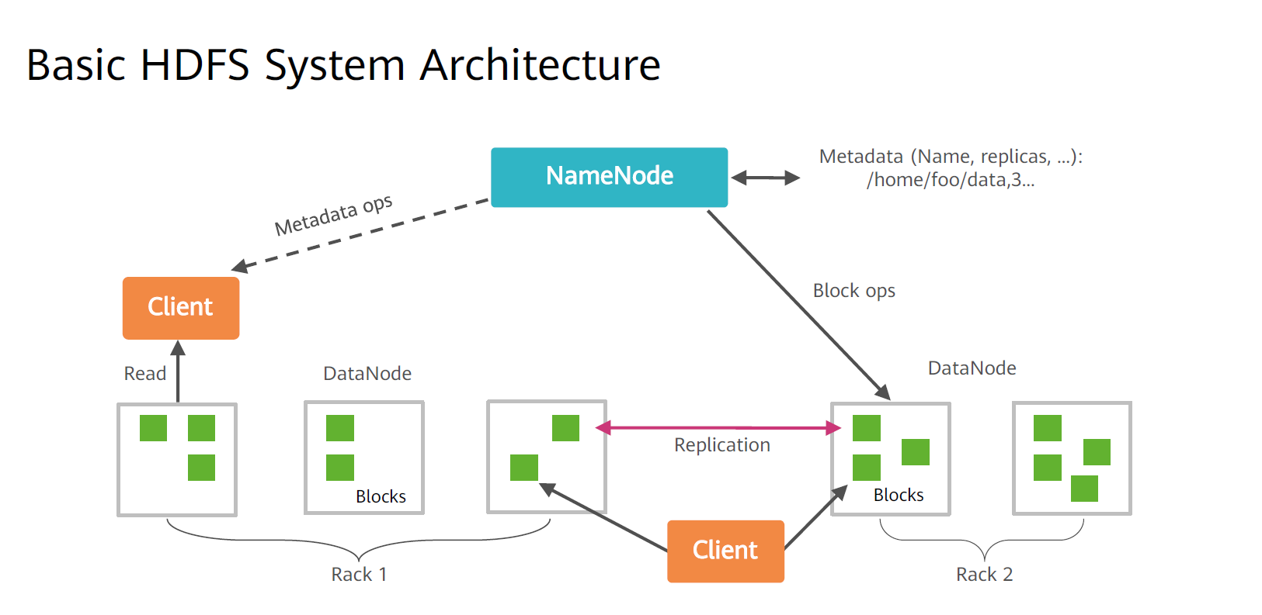

**Basic HDFS system Architecture**

1. **Client**
   * Clients are the most common way of using HDFS.
   * Is a library that contains HDFS interface that hide most of the complexity in the HDFS implementation
   * Client is not a part of the HDFS
   * It supports common operations such as opening, reading, and writing, and providing a shell-like command line mode to access data in HDFS
   * HDFS also provides java APIs that serves as client programming interfaces for applications to access the file system
2. **NameNode**
   * NameNode Manages the namespace of the distributed file system and stores two core data structures
3. **FsImage**: maintain the metadata of the file system tree and all files and folders in that file tree
4. **EditLog**: records all operations on file, such as creation, deletion, and renaming

1. **DataNode**
   * DataNode is the worker node of the HDFS.
   * It stores and retrieves data based-on the scheduling of clients or NameNode
   * Data on each DataNode is stored in the local linux system of the node

**Difference Between NameNode and DataNode**

|  |  |
| --- | --- |
| **NameNode** | **DataNode** |
| Stores metadata | Stores file content |
| Stores metadata in memory | Stores file content in the disk |
| Stores the mapping between files, blocks, and DataNodes | Maintains the mapping between blocks IDs and local files on DataNode |

**Block**

* The default size of block is 128 MB. A file is divided into multiple blocks. A block is the storage unit
* The block has the following benefits
  + Large scale file storage
  + Simplified system design
  + Data backup

**Metadata**

* Metadata = information about the data
* It provides information that describes, explains, or gives content to another data, helping systems and users understand or manage the data
* Metadata helps in searching and organizing data
* Metadata includes
  + File permissions
  + Where each file is stored
  + Size and creation date
  + Which nodes have the pieces of the file

**Namespace**

* Namespace is a container or logical space that holds unique names or identifiers
* A **namespace** is a way to **organize and separate names** so that **identifiers (like file names, variables, or users)** can be reused **without conflict** in different contexts.

**Communication Protocol**

* HDFS is a distributed file system deployed on a cluster, therefore a large amount of data needs to be transmitted over the network
  + All HDFS communication protocols are based on TCP/IP
  + The client initiates a TCP connection to the NameNodes through a configurable port and uses the client protocol to interact with the NameNode
  + The NameNode and the DataNodes interacts with each other through the DataNode protocol

**Disadvantages of the single NameNode Architecture**

* **Namespace limitation**
  + NameNodes are stored in the memory, therefore the number of objects [files, and blocks] that can be contained in NameNode is limited by the memory size
* **Performance Bottleneck** 
  + The throughput of the entire distributed file system is limited by the throughput of the single NameNode
* **Isolation**
  + Because there is only one NameNode and one namespace in the cluster, different applications can’t be isolated
* **Cluster availability**
  + Once the only NameNode is faulty, the entire cluster becomes unavailable

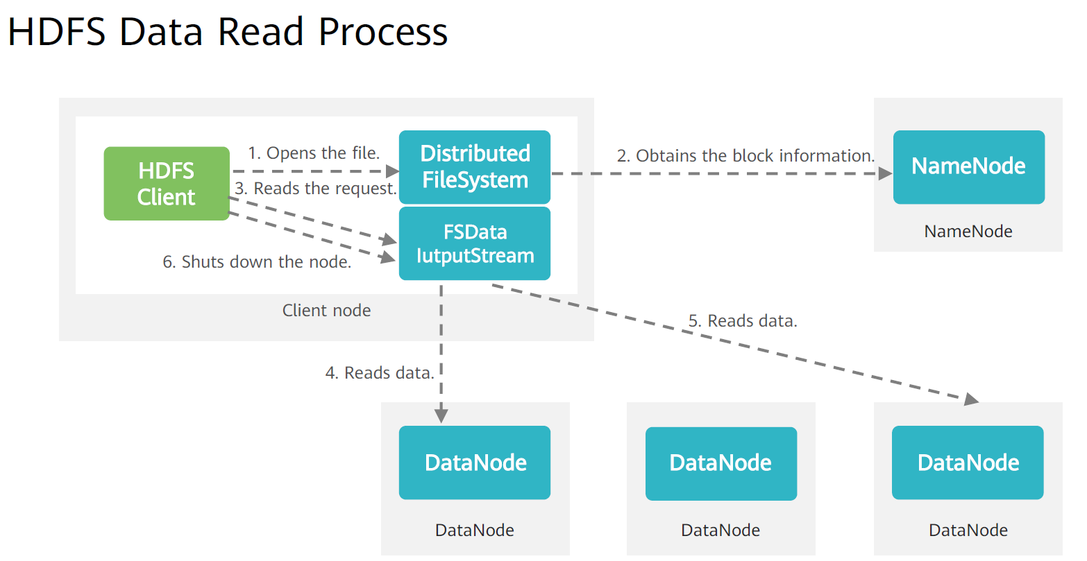

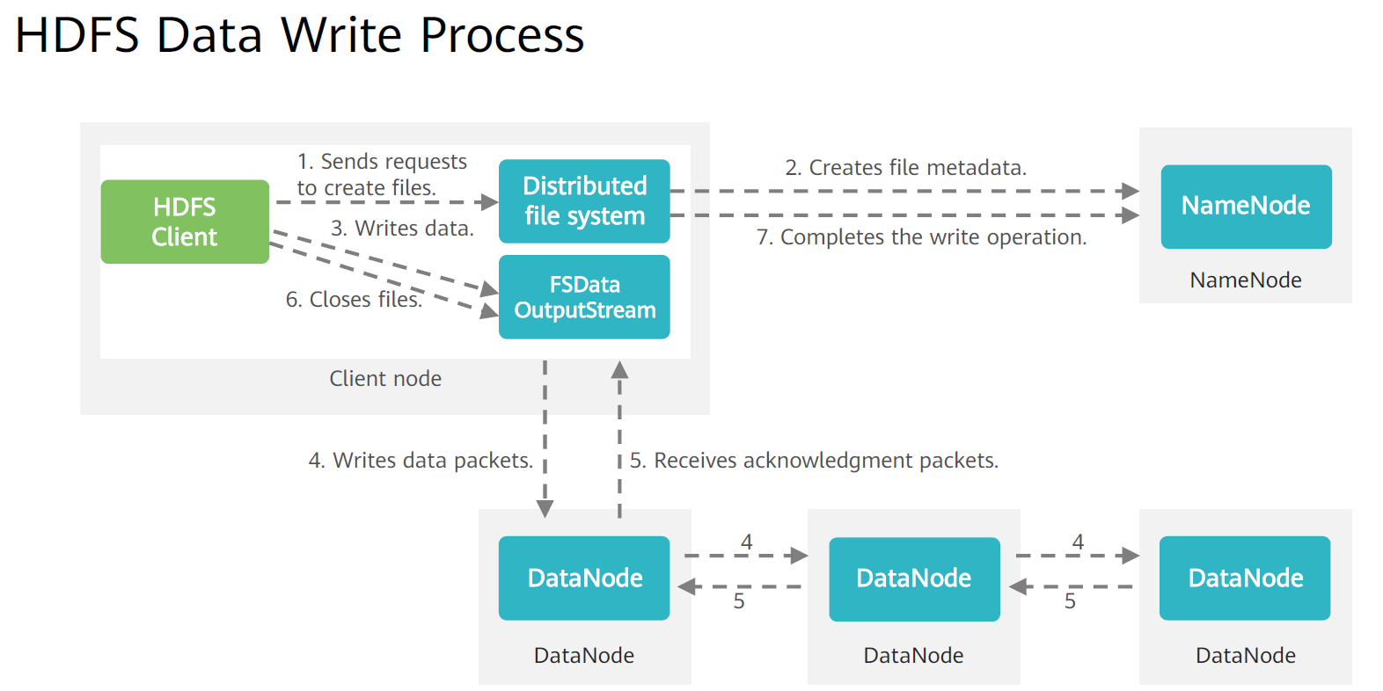

**Zookeeper Overview**

* The zookeeper distributed service framework is used to solve some data management problems.
* Zookeeper is widely used and depended upon by upper layer components, such as Kafka, HDFS, HBase, and Storm
* It provides functions such as configuration management, naming service, distributed lock, and cluster management
* Zookeeper cluster consists of a group of servers. In this group there is only one leader node, with the other nodes
  + the leader is elected during startup
  + zookeeper uses the custom atomic message protocol to ensure data consistency among nodes in the entire system

**Key Features of Zookeeper**

* **eventual consistency** 
  + all servers are displayed in the same view
* **real-time**
  + clients can obtain server updates and failures within a specified period of time
* **reliability**
  + a massage will be received by all servers
* **wait-free**
  + slow or faulty clients can’t intervene in the requests of rapid clients so that the requests of each client can’t be processed effectively
* **atomicity**
  + data transfer either succeeds or fails, but no transaction partial
* **sequence consistency**
  + updates sent by the client are applied in the sequence in which they are sent